Compliance with Post-Intervention Follow-up in the Depressive Pre, Peri and Post-Menopausal Client: A QI Initiative

Terri DeNeui MSN, APRN-BC
Richard E. Gilder, MS, RN-BC
Bioinformatics Scientist/Statistician

Jacqueline Lall Michael, PhD, ANP, WHNP-BC
Faculty Advisor

March 30, 2018

Table of Contents
Abstract................................................................................................................................3
Introduction/Background.....................................................................................................4
Review of Literature............................................................................................................5
Framework.........................................................................................................................12
Purpose…………………...................................................................................................13
Methods..............................................................................................................................15
Project Design........................................................................................................15
Population..............................................................................................................15
Setting....................................................................................................................16
Measurement Methods...........................................................................................16
Procedure………………………...........................................................................18
Data Collection...………………...........................................................................20
Analysis....………...…...…....................................................................................21
Results …………………………………...........................................................................22
Discussion..........................................................................................................................23
Limitations & Implications................................................................................................24
Conclusion.........................................................................................................................26
Tables.................................................................................................................................28
Appendices.........................................................................................................................33
References..........................................................................................................................37

Abstract
Background: Depression in women has been shown to be a leading cause of health disability and decreased health related quality of life (HRQOL). The relationship between depressive symptoms and hormone decline in females has been greatly substantiated in the literature, and androgen therapy has been shown in several small studies to improve depressive symptoms, overall HRQOL and sense of well-being. Quality improvement (QI) initiatives related to screening, situational appropriate treatment and subsequent follow up for depression are lacking for the general population, and non-existent in women experiencing hormone decline and QI initiatives in these areas are needed.
Method: The design for this project utilized a dashboard created in Excel format for data collection and analysis from a retrospective chart review of peri and post-menopausal patients presenting or a hormone consultation. The primary goal was to evaluate compliance with follow up labs, completion of post intervention validated tool, the menopausal rating scale (MRS), and follow-up visit with practitioner for assessment and further intervention.
Results: Compliance with obtaining a pre-MRS survey was clinically, but not statistically, significant at 97.5%(p>0.05). Of the patients who received an intervention, 86% returned for follow up labs and 56% returned for a follow up visit with provider to review the labs and complete a post-intervention MRS survey (p=<0.05).
Conclusion: The results of the QI project revealed needed areas for improvement with follow-up compliance after an intervention. Implementing dashboards for investigating clinic processes regarding follow up may have a positive impact on compliance after an intervention with subsequent improvements in clinical outcomes and HRQOL.
Compliance with Post-Intervention Follow-up in the Depressive Pre, Peri and Post-Menopausal Client: A QI Initiative

Introduction
Hormone decline in women during the third through fifth decades of life, referred to clinically as the menopausal transition (MT), is central to decreased health and quality of life (QOL). This stage of a woman’s life has been reported as the most devastating regarding symptoms and the impact they have on overall functioning and sense of well-being. An often misdiagnosed and mismanaged sequela during this time is depression resulting from hormone decline and exacerbated by symptomatology of hormone decline such as hot flashes and sleep disturbances.
Depression in women is said to be the leading cause of health disability, and depressive symptoms have been shown in several cohort studies to increase two to three-fold during the MT (Hickey, et.al., 2016; Schmidt, et.al., 2015). Of utmost concern is only about 10% of women will report these symptoms to their primary care provider, and many practitioners misunderstand and underestimate the encumbering effects of these symptoms (Woods & Mitchell, 2005).
Quality of care for depression management in primary care, including gynecological settings, has been reported as fair to poor and quality improvement (QI) initiatives in this area are needed (Schoenbaum, et.al., 2001; Wells, et.al., 2000). Several studies report that improved methods of screening and treatment of depression in the primary care setting may directly impact overall sense of well-being and improve health related quality of life (HRQOL) (Schoenbaum, et.al., 2001; Sherbourne, et.al., 2001; Wells, et.al., 2004). A key aspect of QI research is in the area of follow up and adherence to a prescribed regime. Depression treatment and subsequent follow up has been linked to decreased compliance, poor outcomes and decreased HRQOL (Gerber, et.al., 2008). Further, although screening rates and subsequent detection of both major and minor depression have improved across disciplines, there is little data to predict adherence to prescribed regimens, follow up care and long-term outcomes (Gerber, et.al., 2008).
This QI project will address the gap in the evidence regarding follow up after an intervention focused on relief of depressive symptoms in the peri and post-menopausal female. The QI dashboard presented in this manuscript will enable primary care practice leaders to assess levels of non-compliance as well as ascertain areas for improvement in the realm of patient compliance following an intervention.
Literature Review
Depression in Women
The prevalence of depression in women is a widespread, worldwide phenomenon, crossing cultural and ethnic lines with a lifetime prevalence of up to 23% (Ebinger, et.al., 2008; Gyllstrom, et.al, 2007). Depression is twice as likely to occur in women as in men, is a leading cause of dysfunction and disability in women, and noted in several studies to be a key component of decreased QOL and sense of well-being (Davis & Tran, 2001; Gyllstrom, et.al., 2007; Hickey, at.al., 2016; Kumsar, et.al., 2014; McHenry, et.al., 2014; Soares, C., 2017; Rohr, 2002). The differences between men and women in depression rates have also been observed worldwide, and these documented sex differences have led to the scholarly observation that hormone fluctuations are a major contributor (Freeman, et.al., 2004; Freeman, et.al., 2006; Gyllstrom, et.al, 2007; Joffe, et.al., 2016); yet controversy exists as to the specific role the sex hormones, estrogens and androgens, play in this phenomenon (Bromberger, et.al., 2007; Freeman, et.al., 2004; Maartens, et.al., 2002; Panay & Fenton, 2009; Soares, et.al., 2003; Studd & Panay, 2004).
Rates of major depression have been noted in up to 23% for all women, 11% in pre-menopausal women, up to 9% in peri-menopausal women, and nearly 10% in post-menopausal women (Bromberger, et.al., 2016; Lambrinoudaki, et.al., 2015) and depressive symptoms are postulated to be even higher in these groups. Nonetheless, depression and depressive symptoms (also termed minor depression in the literature) in women is a major under-diagnosed phenomenon, secondary to poor screening habits by primary care providers of this vulnerable group (Gilbody, et.al., 2001).
Menopause Transition
The peri-menopausal state has been characterized inconsistently in the literature, however, the consensus definition is the time of irregular menstrual patterns combined with elevated or fluctuating follicle stimulating hormone (FSH) levels preceding menopause, lasting anywhere from 2-8 years (Gyllstrom, et.al., 2007). Menopause means "pause in menses" and is defined as the 12-month time frame after the last menstrual cycle and the cessation of reproductive ability; post menopause is defined as the time frame after menopause (Gyllstrom, et.al., 2007; Sherman, S., 2005; Utain, 1994). Pre-menopause is considered anytime across the reproductive spectrum starting with the first menstrual cycle and prior to peri-menopause.
The terms pre-menopause and peri-menopause, menopause and post-menopause are often interchanged erroneously in the literature, however up to date nomenclature refers to the time period between pre-and post-menopause as the menopause transition (MT) (Sherman, S., 2005). This time in a woman’s life is known to play a pivotal role in vasomotor symptoms and sleep disturbances, both of which have a profound impact on mood changes such as depression (Bosworth, et.al., 2001; Freeman, et.al., 2006; Sherman, S., 2005).
Sex Hormones and Depression
Women journeying through the MT have a higher risk of increased new and recurrent depression (Bromberger, et.al., 2016; Freeman, et.al., 2006; Schmidt, et.al., 2015) and according to Bromberger, et.al., the susceptibility of women over the course of a lifetime to major depression is substantial (2015). Common symptoms reported during the MT besides depressive mood include fatigue, irritability, anxiety, memory loss, brain fog, joint pain, low libido, sexual dysfunction, night sweats and insomnia, all of which may exacerbate the symptoms of depression; of these, sleep deprivation has the most significant compounding on exacerbation of depressive symptoms.
It has been postulated that estrogen is a woman’s key hormone, and estrogen decline has been the primary area of focus for research in depression during the MT. Estrogen deficiency plays a pivotal role in new onset and exacerbation of existing depressive symptoms during the MT (Freeman, et.al., 2004; Joffe, et.al., 2016; Joffe, et.al., 2018; Schmidt, et.al., 2015). Additional data, however, supports the potential greater role androgens play in neuropsychology, and demands further exploration and study (Davis & Wahlin, 2015; Ebinger, et.al., 2008; Glaser, et.al., 2013; Jovanovic, et.al., 2015; Kumsar, et.al., 2014; McHenry, et.al., 2014; Rech, et.al., 2016). Dimitrakakis (2011) states: "Androgen receptors are found in virtually every tissue in both women and men from the brain, breast, and bones, indicating the role they play in normal tissue homeostasis and possible pathologies including breast cancer, osteoporosis, libido and neuro-psychological and neuro-cognitive decline" (p. 533).
The hippocampus and amygdala, critical regions in the brain owing to incidence of depression, are rich with androgen receptors, a key explanation of clinical response with androgen therapy (Ebinger, et.al., 2008). Kumsar, et.al., concluded sub-optimal testosterone levels in depressed women compared with women in a control group points to the role testosterone may play in depression (2014). One explanation of this phenomenon is serotonin plays a key role in the development of depression, and testosterone, as well as estrogen, has been shown to modulate serotonergic transmission (Jovanovic, et.al., 2015). Laboratory reference ranges for testosterone in women have not been established, however levels under 30 ng/dl have been consistent with the non-specific symptoms of androgen deficiency such as depressive mood and decreased sense of well-being (Miller, et.al., 2004).
Although historically considered a male hormone, women exhibit greater sensitivity to decline and subsequent replacement of testosterone than men and testosterone is reported to be an essential hormone for women (Davis & Wahlin, 2015; Miller, et.al., 2007; McHenry, et.al., 2014). Androgen replacement has been shown improve mood, lift anxiety and depression, and improve sleep patterns (Bachmann, 1999; Carnahan & Perry, 2004; Davis, et. al., 2001; Davis & Tran, 1999; Dokovic, et.al., 2015; Ebinger, et. al., 2008; Frye, et.al., 2009; Glaser, et.al., 2011; Glaser, et.al., 2013; Glaser & Dimitrikakis, 2013; Hodosy, et.al., 2012; McHenry, et.al., 2014; Miller, et.al., 2007; Miller, et.al., 2009; Nappi & Lachowsky, 2009; Osborne, et.al., 2009; Panay & Fenton, 2009; Sands & Studd, 1995; Schutter, et.al., 2005; Studd & Panay, 2004; Zarrouf, et.al, 2009).
Despite the plethora of data to support androgen replacement as an individual or adjunctive hormone treatment option in women globally, and the fact that it has been used safely and effectively in women for almost a century (Maclaran & Panay, 2012), androgen deficiency is not the focus of assessment, diagnosis and subsequent treatment for depression in females. Part of the reason for these findings is related to the great deal of confusion and myths surrounding androgen replacement in women (Glaser & Dimitrakakis, 2013). This is of grave importance as the primary place women seek relief from depression is with their PCP, and these states often go unrecognized in primary care (Gilbody, et.al., 2001).
Screening and Follow up for Depression
The literature review regarding screening for depression in primary care provided mixed reviews, with some analysis reporting little usefulness of routine screening for depression improving patient outcomes (Gilbody, et.al., 2008; Thombs, et.al., 2012). Other studies, including the US Taskforce Systematic Review on this topic, concluded routine screening for depression confers the most positive outcomes when combined with systematic processes and sufficient staff support for screening, treatment and follow up (Pignone, et.al., 2002; O’Conner, et.al., 2009). Gilbody. et.al., meta-analysis concluded utilizing standardized screening tools for depression without organizational structure is not beneficial (2008).
The literature review regarding compliance with follow-up after an intervention was minimal and varied. There were no data articles found addressing screening, treatment and compliance with follow up for depression during the MT. The literature supported the concept of a growing number of efficacious treatments for various disorders, however low adherence to treatment regimens and poor follow up can undermine the effectiveness of the therapies (Haynes, et.al., 2002; McDonald, et.al., 2002). Haynes further concluded, although accurate measures of compliance are lacking, many practitioners can implement incremental process changes such as educational platforms, counseling, appointment reminders, involving family and rewards for patient adherence to a regimen that can greatly affect long term compliance and subsequently improve outcomes (2002).
Most literature regarding compliance with follow up was in the realm of discharge from tertiary care to primary care, and the majority of that data was focused on compliance with following a prescribed medication treatment. A large observational study followed over 2000 behavioral health patients, discharged from a tertiary care center after diagnosis, for 2 years to determine the numbers lost to follow up on referral to primary care for treatment; the results concluded detection of mental health disorders were high, however follow up and continuity of care was undetermined, potentially resulting in poor outcomes in this population (Gerber, et.al., 2008). As the literature is lacking regarding understanding patient adherence to various treatments and follow up for behavioral health issues, the development of theoretical models to explore this topic further is necessary (Christensen, et.al., 2009).
Quality Improvement for Depression
The literature review did not exhibit a great deal of data specific to addressing screening, follow up or quality improvement (QI) initiatives related to depression in women going through the menopause transition, however a recent study reported approximately 2 million women enter the MT annually, and because of the encumbering effects of depression in this vulnerable group, universal screening for depression during the MT was recommended (Hickey, et.al., 2016).
Several studies addressing QI initiatives focused on screening, intervention and follow up for depression show both short term and long-term initiatives improve patient outcomes of depression (Sherbourne, et.al., 2001; Schoenbaum, et.al., 2001; Wells, et.al., 2000). Wells, et.al., continued the original research from 2000 in a randomized controlled trial on QI initiatives that showed a positive impact on depression outcomes five years after implementation when organizational structures were in place to support ongoing care and follow up (Wells, et.al., 2004).
One large study of over 2000 practitioners across several disciplines, family practice, internal medicine and gynecologist, revealed QI initiatives targeting improved depression outcomes need to be tailored to differentiate between the specialties (Williams, et.al, 1999). Specific recommendations for improvement included educating healthcare providers on the differences between major depression and depressive symptoms related to life change (hormonal) or stressors (situational); and to address organizational and knowledge barriers to best practice in treating depression, including the gaps in the knowledge appropriate treatment depending on the etiology (Williams, et.al, 1999; Gerrity, et.al., 2001). A recent report by Soares, concurs with the Williams study, noting the importance of taking into consideration depressive symptoms expressed in the MT may respond differently to conventional treatments for major depression (2017). Further, differentiation between the DSM IV diagnosis of major depressive disorder (MDD) and depressive symptoms is paramount to appropriate screening and subsequent treatment and follow up (Soares, C., 2017).
Why is there so little data on QI initiatives in primary care in the US? In researching this question, a common theme was revealed: lack of continued support from leaders and practice managers, lack of practitioner and practice incentives, and lack of collaborative care teams in primary care (Bray, et.al., 2009; Parand, et.al., 2012; Schoen, et.al., 2006). One report addressed this issue in a study comparing primary care practices globally, and noted although the US spends more money on healthcare, there are little incentives for primary care practices to focus on quality and institute QI initiatives, and that policy changes in the US could lead to improved performance in primary care, directly impacting patient outcomes. (Schoen, et.al., 2006).
Framework
Iowa Model of Evidence Based Practice
The Iowa Model provides a framework from which to address a practice problem systematically, resulting in the evaluation of evidence from the practice and the formulation of evidence based practice changes intended to improve clinical outcomes utilizing the following steps:
- Identify a trigger in a clinical practice.
- Identify and assess the relevance of the trigger to the clinical practice.
- Form a clinical team to critique and synthesize existing evidence related to the trigger and/or conduct a study within the practice for use in practice change.
- Assess for sufficient evidence to pilot the change in practice; if not enough evidence, further research is conducted to generate a new evidence.
- If the implemented change is appropriate for adoption in practice, the change is instituted. If not, continued evaluation of the quality of care and new evidence is implemented.
- Ongoing evaluation of the change is disseminated.
(Melnyk & Fineout-Overholt, 2015).

A key aspect of the Iowa model useful for identification of the problem question asked for this project, was the integration of conducting a study within the practice to assess the clinical question. In the context of this project, the model provided a framework to assemble research defining the practice issue or “trigger”, compliance with post intervention follow up; utilize evidence systematically obtained from the practice to evaluate the extent of the issue, and evaluate and make decisions regarding the evidence to subsequently plan evidence based change. The model also provides a framework for piloting the evidence based practice change and future evaluation of the implemented change for improved patient outcomes (Appendix A).
Purpose
It is paramount that primary healthcare practices evaluate processes and treatment outcomes continually for quality improvements. Many healthcare providers have a general, subjective idea of the outcomes of their interventions, but succinct and systematized methods of collecting and evaluating concrete data is lacking in many primary care and specialty practices. Impactful measurement of whether an intervention produces a statistically significant change must include a statistically powered measure of compliance with all aspects of the intervention, including follow-up. The long-term goal of this author is to statistically measure symptom change in peri and post-menopausal women who undergo an androgen therapy intervention with a pre-test post-test design. Prior to a pre-test post-test analysis, however, the percentages of patients who follow through with the treatment plan, including follow up and re-assessment, must be evaluated to assess the need for process improvements.
To effectively and continuously collect data and monitor intervention outcomes in the study site, including follow up over time, a QI dashboard was needed. The immediate purpose of the dashboard was to assess the extent of the issue of compliance with the prescribed treatment regime, and based on that information further evaluate the need for process change and implementation within the organization. The development of the QI dashboard will serve a dual purpose, not only for evaluating compliance with follow up, but also for gathering data for future evaluation of outcomes and potential additional QI initiatives to improve overall patient care, thereby positively impacting HRQOL.
PICO Question:
In pre, peri-and postmenopausal women who self-report moderate to severe depressive symptoms and receive an intervention with sex hormone therapy, what percentage are compliant with post intervention laboratory assessment and follow up visit?
Primary Objectives
- Identify percentage of patients receiving an intervention who completed the Pre-treatment MRS tool.
- Identify percentage of patients receiving an intervention who completed the Post-treatment MRS tool.
- Identify percentage of patients receiving an intervention who completed the post-treatment laboratory data.

Methods
Project Design
The design for this project utilized a dashboard created for data input and analysis from a retrospective chart review of all female patients presenting new to a hormone specialty practice from January 1, 2017 through August 31, 2017 with an appointment type of “hormone consultation”. Because of the nature of this project design, IRB approval was not required. The report for this information was retrieved from the practice’s electronic health record (EHR). Data collected for analysis was input to the dashboard on the following items of interest:
- Number of new hormone consultation patients to the practice.
- Number that received an intervention.
- Number who received an intervention and completed a pre- and post-hormone therapy intervention Menopausal Rating Scale (MRS).
- Number who received an intervention and had post intervention laboratory assessment.
- Pre-and post-intervention MRS scores on depression data was recorded for future analysis of pre-and post-intervention comparison scores.
Population
The population of study for this project was females across the reproductive spectrum with self-reported symptoms of sex hormone deficiency with corroborating lab tests who presented new to the practice setting from January 1, 2017 through August 31, 2017 for a hormone consultation. The sampling method was a non-probability convenience sample, of which patients who met the inclusion criteria were between the ages of 18-57, with a median age of 49 (Table 1).
Inclusion Criteria:
- Able to read English.
- Completed a pre-treatment MRS at baseline.
- Received an intervention of androgen or androgen/estrogen combination therapy via subcutaneous pellet insertion.
Exclusion Criteria:
- Did not receive the intervention.
- Did not complete a pre-treatment MRS.
Setting
The setting was a primary care hormone/endocrine specialty practice that sees approximately 500 female patients per month for hormone related issues; 10-15% of which, on average, comprising new patients to the practice. The practice has 2 locations, employees 30 staff members including 6 Nurse Practitioners who are the primary care providers.
Measurement Methods
The Health-Related Quality of Life (HRQOL) Menopausal Rating Scale (MRS) (Appendix B) is an open access, reliable, validated tool that is widely used in 9 countries, available in 22 languages, and has been used in several research studies to evaluate the effectiveness of hormone therapy interventions (Dinger & Heinemann, 2014; Heinemann, et.al., 2004). The self- administered Likert-scale assesses symptoms and complaints of women such as psychological, somato-vegetative, and urogenital; evaluates the severity of symptoms over time, and measures changes in symptom severity before and after a hormone replacement therapy intervention (Dinger & Heinemann, 2014; Glaser, et.al., 2011; Heinemann, et.al., 2004).
The scale utilizes a 5-point rating system that allows the patient to rate symptom severity as none (0 points) mild (1 point) moderate (2 points) severe (3 points) and extremely severe (4 points) (Dinger & Heinemann, 2014; Glaser, et.al., 2011; Heinemann, et.al., 2004). The categories (sub-scales) correlate to specific questions: somatic questions are numbers 1,2,3,11; the psychological questions are numbers 4,5,6,7; and the urogenital questions are 8,9,10. This format allows the practitioner to rate each sub scale independently or look at specific complaints within the subscale individually for improvement. A decrease in symptom severity score over baseline of at least 4-7 points must be present to establish clinical significance (Dinger & Heinemann, 2014). For the purposes of this QI project, question number four on the scale addressing the symptoms of depression were a key area of focus.
MRS Reliability and Validity
In a comprehensive review utilizing a large multinational survey, the reliability and validity of the MRS tool was analyzed. The results of this review revealed internal consistency coefficients ranging between 0.6 and 0.9 across the 9 countries, statistically significant for reliable consistency; further they reported a test-retest, Pearson's correlation coefficient (r) that showed statistically significant temporal stability of the total scale and its three sub-scales (Heinemann, et.al., 2004). Heinemann (2004, p 1) also concluded the validity of the tool to be stable, and suggests "the scale measures constantly the same phenomenon in symptomatic women" and is a "high quality tool to measure and compare HRQOL of aging women in different regions over time" (p.2). In an earlier study by Schneider, et.al., (2000) the scale was noted to be statistically reliable with a Pearson’s correlation coefficient of r= 0.60.
In a study by Dinger & Heinemann (2014) it was concluded the MRS scale was a suitable tool to measure the effect of hormone treatment across the entire spectrum of symptomatology of the menopause transition; further, as compared to clinical judgment of the clinician, the tool yielded more consistent, stable and uniform results. Other studies measuring degree of symptoms and/or relief from menopausal symptoms after hormone therapy with the MRS have been found in the literature with statistically significant results (Ashan, et.al., 2015; Chedauri, et.al., 2007; Chuni, et.al., 2011; Glaser, et.al., 2011; Morovcova, et.al., 2014; Rahman, et.al, 2010; Wuttke, et.al., 2003).
Procedure
Every new female patient to the practice being seen for a hormone evaluation consultation, with or without treatment, completes a baseline MRS questionnaire along with comprehensive laboratory data to evaluate the subjective and objective presence of hormone deficiency, as well as assess the subjective severity of symptoms in the three common domains: somatic, psychological and urogenital. The MRS tool not only assesses baseline status for comparison data, but also assists the healthcare provider in formulating an individualized plan of care for the patient at consultation and again at follow up.
After assessment and evaluation of pertinent subjective and objective data, the clinical plan is implemented. If the patients clinical picture is one of estrogen and/or androgen deficiency syndrome (ADS), treatment options for hormone replacement are discussed with the patient and informed consent is obtained. The treatment of choice for hormone replacement in the study clinics is subcutaneous hormone pellet implant. Response to treatment is gradual with a peak response at 4-5 weeks post pellet insertion, hence the timeframe for follow up data collection and visit with practitioner.
The pre- and post- MRS questionnaires are electronically printed with the patient’s chart ID number and filled out by hand by the patient prior to the visit with the practitioner; after the initial consultation, the form is then scanned and uploaded into the patients EHR. There are multiple staff members involved in the process of the pre-intervention MRS data collection: the front office coordinators who give the patient the tool to fill out upon arrival with the rest of their initial paperwork; the medical assistant who takes the patient back to the room for intake and review of paperwork; the nurse practitioner (NP) who reviews the initial MRS with the patient along with other pertinent data; and lastly the check-out coordinator who scans and uploads the completed survey directly into the patients EHR under a designated tab labeled "MRS."
At the close of the initial intervention appointment, the patient is scheduled to receive post therapy lab work at 5-6 weeks post intervention, and a follow up appointment 6-7 weeks after therapy. At the follow up visit, a post-intervention MRS questionnaire is obtained following the same steps outlined in the pre-intervention collection. Results of the patient’s post-intervention laboratory work and post- intervention MRS questionnaire are analyzed, compared to pre- intervention data and reviewed by the NP with the patient at the follow up appointment; adjustments to therapy, if needed, are made at that time. The patient is reevaluated and treated on a PRN basis, the average timeframe of which is 3-4 months for females (see process flow chart, Appendix C).
Data Collection
Dashboard Creation
The dashboard for data collection of this retrospective chart analysis was created in Excel format and placed on the clinic’s Microsoft Office 365 secure SharePoint platform. The goals of this project were two-fold: the primary goal was to create a dashboard for data collection to evaluate compliance with follow up labs and visit with practitioner and completion of post-intervention MRS; the secondary goal was to utilize the dashboard to collect data for future evaluation of statistically significant changes in symptoms of depression after initiation of androgen therapy, and to evaluate need for further interventions and follow up for patients whose post MRS depression scores remained equivocal or worsened.
The primary de-identified data collection sheet for this project included columns for patient’s age, appointment date, presence of pre-MRS documentation, intervention verification, presence of post lab documentation, and presence of follow up appointment/post MRS documentation, indicated by a “yes” (present) or “no” (absent) (Appendix D). An additional Excel spreadsheet was created for future evaluation of response to treatment, and included a column for the pre-intervention MRS depression score, a column for the post-intervention MRS depression score, and three subsequent columns for decreased, equivocal and increased scores respectively; the last column computed a calculated change in rating between the pre-and post-scores for each patient (Appendix E).

Data Collection Process
Once the data collection spreadsheets were created, a report of all new female patients to the practice since January 2017 was obtained by generating a report from the clinics EHR based on appointment type. Inclusion criteria was utilized to filter charts to be reviewed for the study. Once charts of patients who meet inclusion criteria were obtained, the pre-and post-treatment MRS for that patient was checked for correlating medical record numbers that were consistent with the patient medical record number prior to downloading.
Once the individual pre/post surveys were identified, they were directly downloaded and stored in designated folders on a Microsoft Office encrypted remote desktop for future analysis of results. Next, the patient’s EHR was reviewed for the variables of interest for this QI project: post intervention lab work and follow up appointment, noted by presence of the post intervention lab results and the post-intervention MRS survey in the patients EHR. As data was collected, it was logged into the dashboard spreadsheet in the rows corresponding to the patient’s medical record number to indicate the presence, indicated by “yes” or absence, indicated by “no” of the variables of interest.
Analysis
Data collected from the dashboard spreadsheet was re-coded as nominal data to utilize the Chi-Square test for statistical analysis, with 0=no, and 1=yes. Data was input and analyzed in SPSS by calculating percentages of new hormone consultation patients to the practice that met inclusion criteria and returned for follow up lab work and returned for a subsequent follow up visit to review labs and complete the post MRS tool.
Results
A total of 484 patients were seen during the study time frame for an initial hormone consultation. Of the 484 patients seen for initial consultation, 450 received the intervention. Although the primary area of interest in the realm of compliance for this project was patient compliance with post-intervention follow up, the dashboard data revealed three areas of compliance for review: compliance of clinical staff with obtaining a pre-MRS survey on all new consultations, the compliance of patients returning for the post intervention lab work, and compliance of patients returning for the follow up visit to evaluate labs and subjective response to treatment with the post-MRS survey.
Analysis of compliance of the clinical staff in obtaining a pre-intervention MRS survey was clinically significant at 97.8%, however was not statistically significant due to limited sample size (Chi-Square Fisher’s Exact, df 1, N484, p=.203) (Table 2). Of those who received the intervention, 84% were compliant with post intervention lab work and 56% were compliant with the follow up visit and completed post-intervention MRS survey (Chi-Square Fishers Exact, df 1, N484, p= 0.000) (Tables 3 & 4). Statistical analysis of all three variables, patients who received the intervention, completed the pre-and post MRS and the follow up lab work was 53% (Chi-Square Fisher’s Exact, df 1, N484, p= 0.000) (Table 5).
Of mention, initial analysis of the pretest/ posttest MRS scores for future research related to depression were promising. In patients who rated depression prior to the hormone therapy intervention as moderate to severe (n133), 87% reported a decreased in depressive symptoms (n116), 11% reported an equivocal rating of depressive symptoms (n14), and 2% reported an increased rating of depressive symptoms (n3). Analysis of the change in depression scores between pre-intervention MRS and post-intervention MRS showed a statistically significant change in depressive symptoms post intervention (Mann-Whitney U 8,146, N388, p = 0.000, two-tailed) (Appendix F).
Discussion
The results of this project reveal that even in a hormone specialty clinic, who’s processes have been dynamically changing as the practice has grown, there are still major areas for improvement of internal processes and partnership with patients for improved compliance with follow up and ongoing assessment of treatment outcomes. The dashboard revealed several areas of needed investigation for future analysis and QI interventions.
The dashboard as an intervention to evaluate compliance with follow up after hormone therapy in depressed patients, as well as staff compliance with initiating the utilization of a validated tool to assess outcomes, proved an effective tool to examine potential areas for process improvement. Currently, an integral part of the follow up process from the clinic is a call from the medical assistant at three weeks post intervention to check in with the patient and remind them of their upcoming lab visit, this process may explain the higher level of compliance with the lab draw appointment over the follow up visit one week after lab draw.
The clinic initiates automated text message reminders of all appointments one week prior with an option to reply with “yes” to confirm; unconfirmed appointments are notified by phone 72 and 24 hours prior to the appointment to further attempt confirmation, however breakdowns in these processes could explain some of the variation in follow up visit results. A major strength of the dashboard created for this study is the ability to utilize it for ongoing investigation of these and other areas of compliance within the clinics.
Limitations and Implications
Considering the follow up compliance from lab draw (86%) to follow up visit to discuss lab results and complete a post-intervention assessment (56%) so drastically dropped, there is clearly room for investigation of processes and implementation of quality improvement initiatives. A major limitation to the project results is that compliance from the staff with actually scheduling the follow up lab and post-intervention/MRS visits at the initial appointment was not investigated. An additional variable not investigated, resulting in a study limitation, was the utilization of the text reminder feature for the follow up visit appointments as a possible breakdown; if the text reminder feature had not been set to the specific follow-up appointments in the EHR treatment pathway, it could explain the drastic reduction in follow up visits.
Some limitations to the generalizability of the project results to medical practices implementing hormone treatment (HT) interventions are worthy of mention:
- The inclusion of variables of hormone status at presentation, such as pre/peri or post-menopause was not included.
- The inclusion of variables of hormone replacement needed, such as androgen only or androgen plus estrogen was not included.
- The specific flow of patient interaction after a hormone pellet intervention was not considered; not all HT interventions require specific protocols of time intervals for repeat lab tests and follow up appointments.
- The study only analyzed data over eight months, thereby neglecting to control for potential seasonal variations.
Future Implications and Opportunities
Analysis of the dashboard data revealed a key area for investigation of process improvement, compliance with follow up appointment and obtainment of the post-intervention MRS tool. A future process to consider implementing would be to ensure post-intervention appointments are not only scheduled at time of initial therapy appointment, but that appointment is confirmed and the importance expressed during the three-week follow up call by the medical assistant mentioned previously.
One potential process change could be initiating the post-MRS tool at the lab draw appointment, however a limitation to that process change idea is the fact only about 50% of the patient population gets their labs drawn at the clinic, the other 50% utilize remote draw stations that offer more convenient hours or locations closer to the patient’s home. Another consideration would be to implement an email with the post-MRS tool as part of the automated EHR treatment pathways; however, obtaining the tool is only one aspect of the post intervention follow up appointment. Reviewing the tool and assessing results of the intervention with the patient to implement subsequent changes in the treatment plan is paramount to improved patient outcomes. Investigation of these areas in the future will provide additional insights for clinic leaders to assess prior to initiating organizational changes.
Lastly, it is worthy of mention the future implications of statistical analysis of how well the intervention provided symptom relief in the areas investigated. Utilizing the pre/post MRS intervention results pertaining to depression scores, and investigating follow up in patients with no change in depressive symptoms can have major future implications for improving quality of care in this population. Further, utilizing the dashboard to investigate the other items on the pre/post MRS scale such as somato-vegetative, urogenital and the additional neuro-psychological measures may have a major impact on HRQOL outcomes in the peri and post-menopausal female, as additional published literature on the role of androgen decline in depression, anxiety, mood changes and other QOL indicators, such as sleep patterns and sexual well- being, as well as safety and efficacy of androgen therapy in women is needed (Ebinger, et.al., 2008; Glaser, et.al., 2011; Goldstat, et.al., 2003; Miller, et.al., 2009; Panay & Fenton, 2009).
Conclusion
The burdensome symptoms of depression in women going through the menopausal transition are a highly underdiagnosed global issue, and the far-reaching impact of restoring hormonal homeostasis on quality of life is an often-misunderstood phenomenon in both the healthcare and lay communities. It is imperative primary healthcare providers expand their horizons in the areas of not only screening for and investigating treatment alternatives to hormone related depression, but also to explore compliance with follow up measures to improve outcomes in this vulnerable population.
Implementing dashboards for investigating clinic processes ensuring adequate treatment response through follow up is a key area for QI initiatives in primary care practices. In the clinic population being investigated for this study, the proportion of patients who received the intervention and completed the follow up lab work and follow up visit was low at 53%. Investigation of the “why” behind poor compliance with follow up, as well as initiating process improvements in the area of compliance with follow up after an intervention, will be paramount to assessing safety and efficacy of a treatment intervention as well as provide much needed data for future research.
In the future, given the clinical application of androgen and its effects on the regions of the brain primarily responsible for depressive symptoms, this therapy as a treatment alternative may have far reaching implications beyond peri and postmenopausal women, and prove efficacious in other areas of neuropsychology. The dashboard may serve as a feasible tool to collect safety and efficacy data on the use of androgen therapy, alone or in combination with usual care, as a viable treatment alternative for hormonally encumbered women, thereby directly impacting HRQOL.
Ongoing retrospective analysis and future publication of results utilizing androgen therapy for depression relief and improvement in other areas of symptomatology in peri and post-menopausal women may help pave the way for increasing provider awareness of what Glaser & Dimitrikakis refer to as a highly undervalued and underutilized therapy (2013).

Table 1. Mean distribution of age chart and histogram:

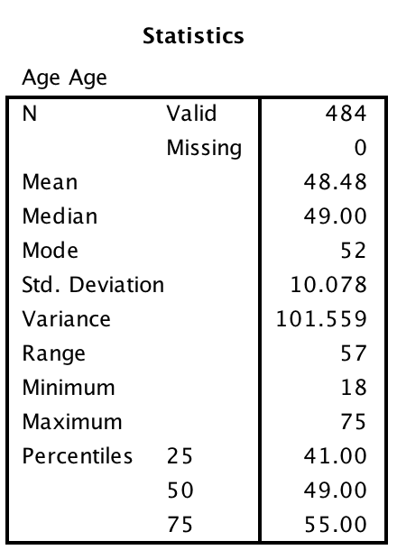

Table 2. Chi-Square table and graph of intervention and pre-MRS compliance:
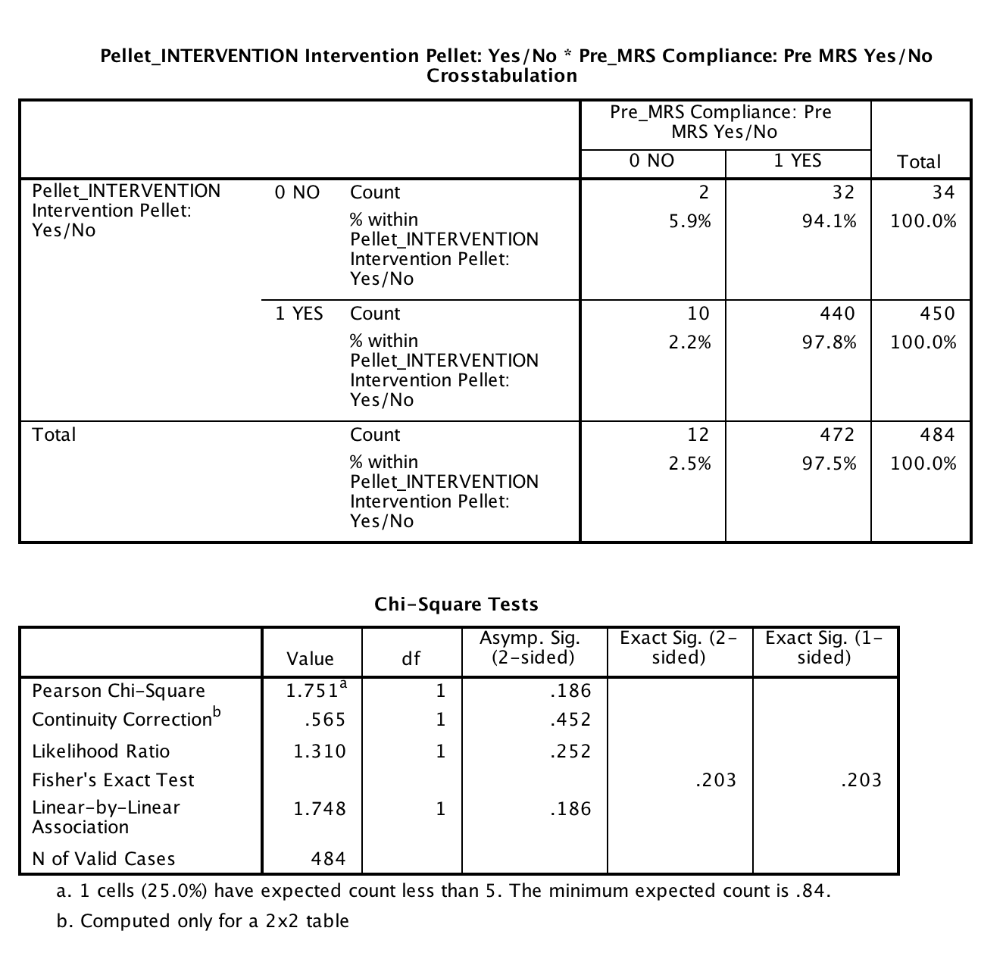

Table 3. Chi-Square table and graph of intervention and post-lab compliance:
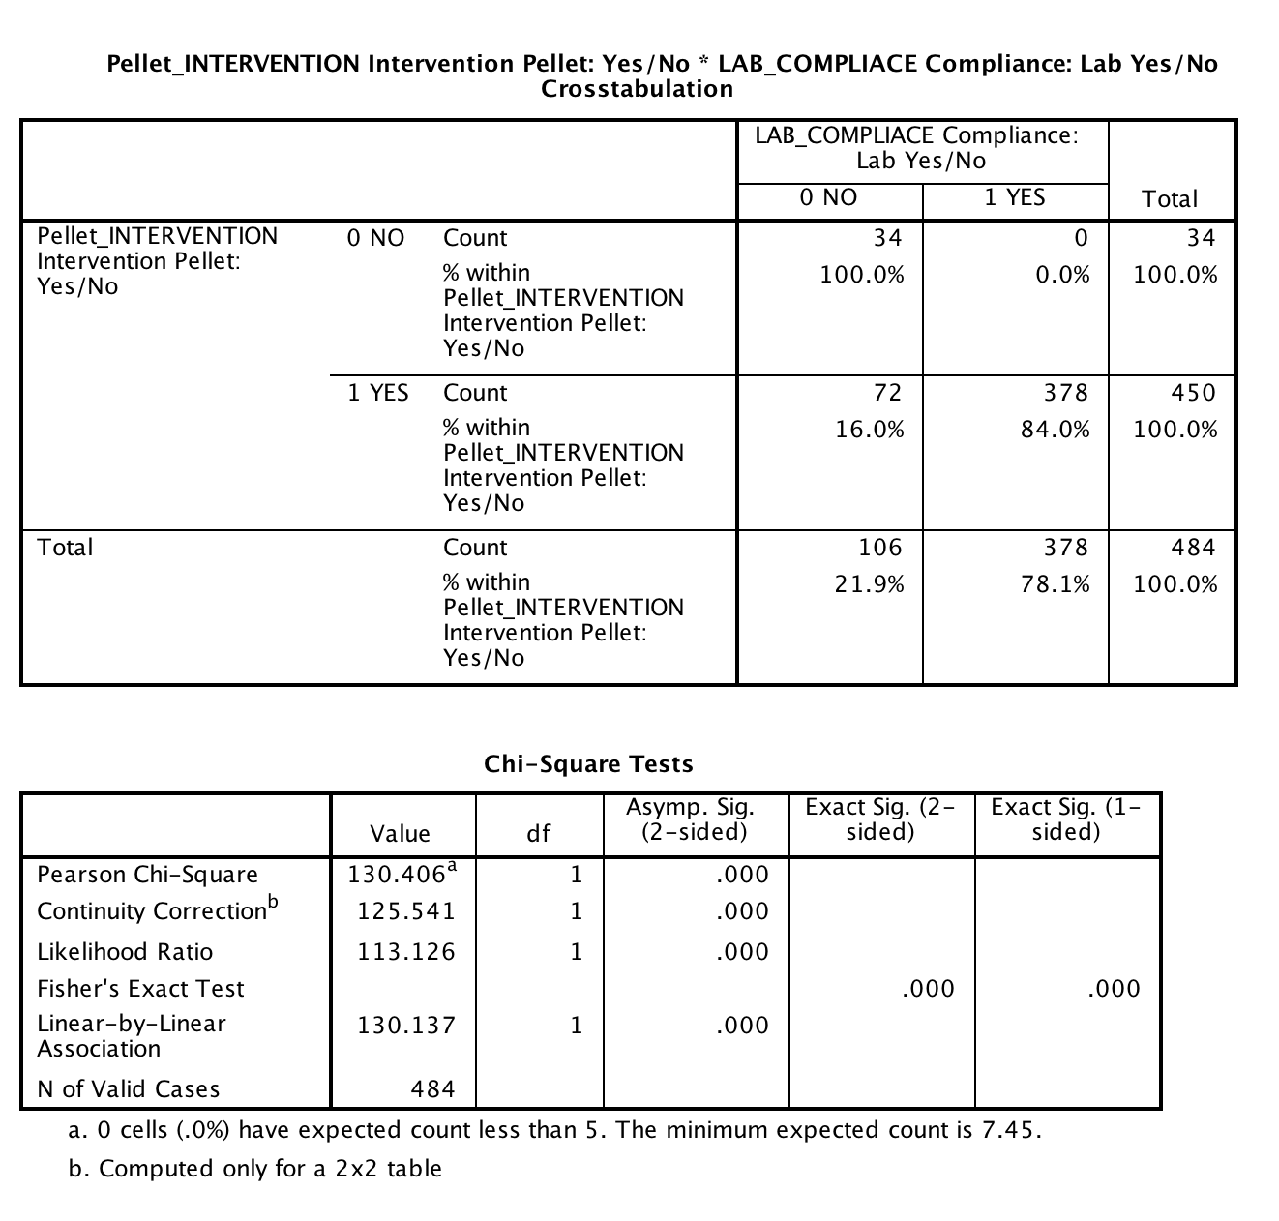

Table 4. Chi-Square table and graph of intervention and post-MRS compliance:
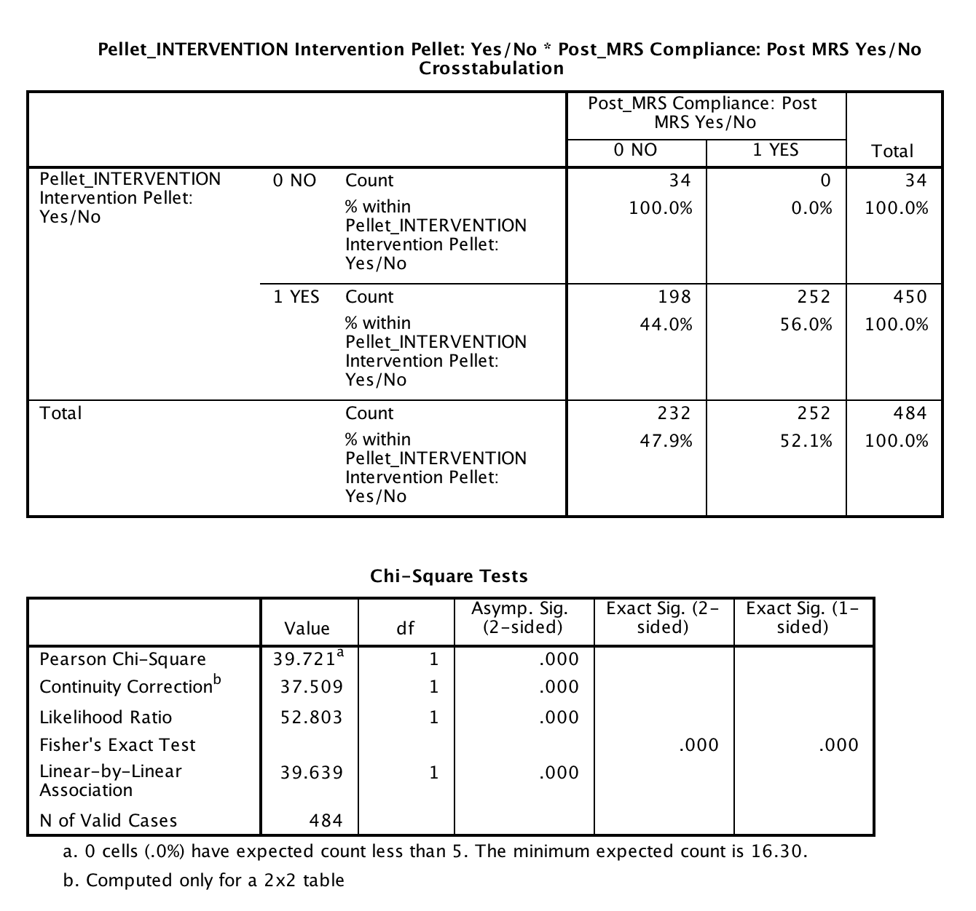
Table 5. Chi-Square table and graph of intervention and pre/post MRS and post lab compliance:
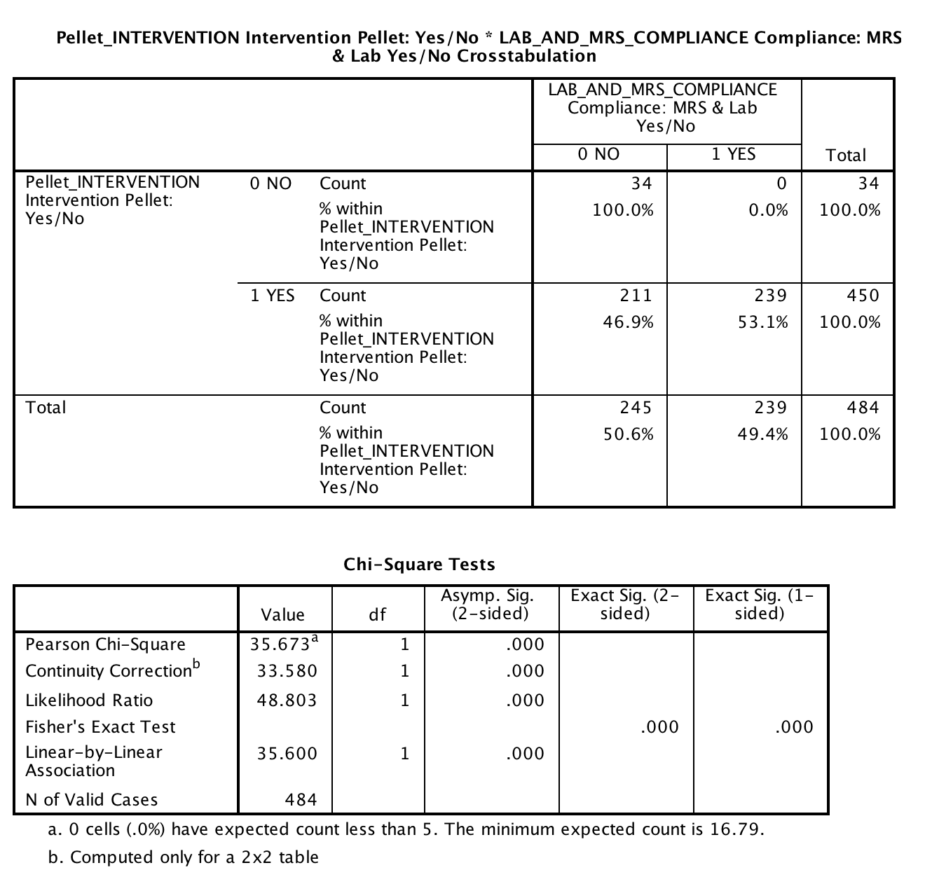
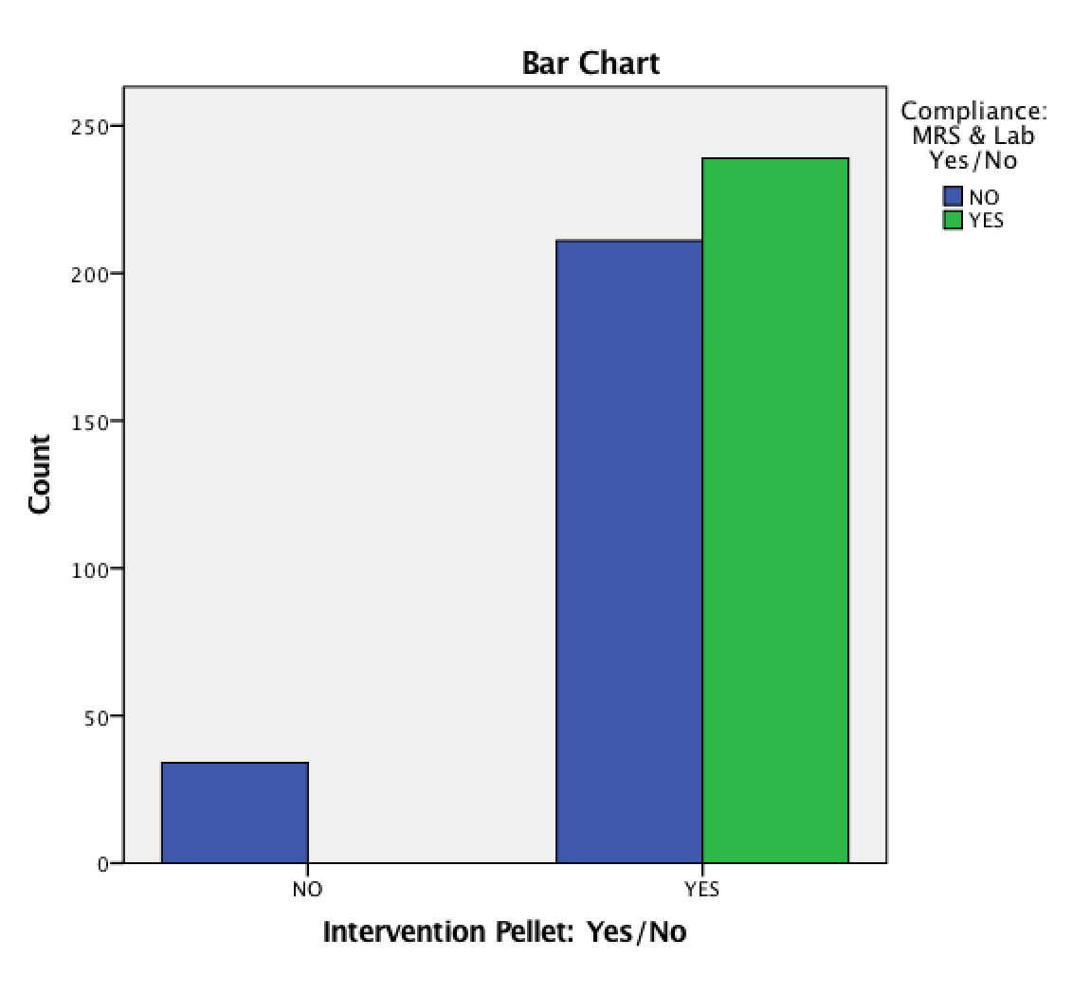
Appendix A: Iowa Model for Evidence Based Practice Change:
Follow–up Compliance after Hormone Therapy Intervention

Appendix B: Menopausal Rating Scale
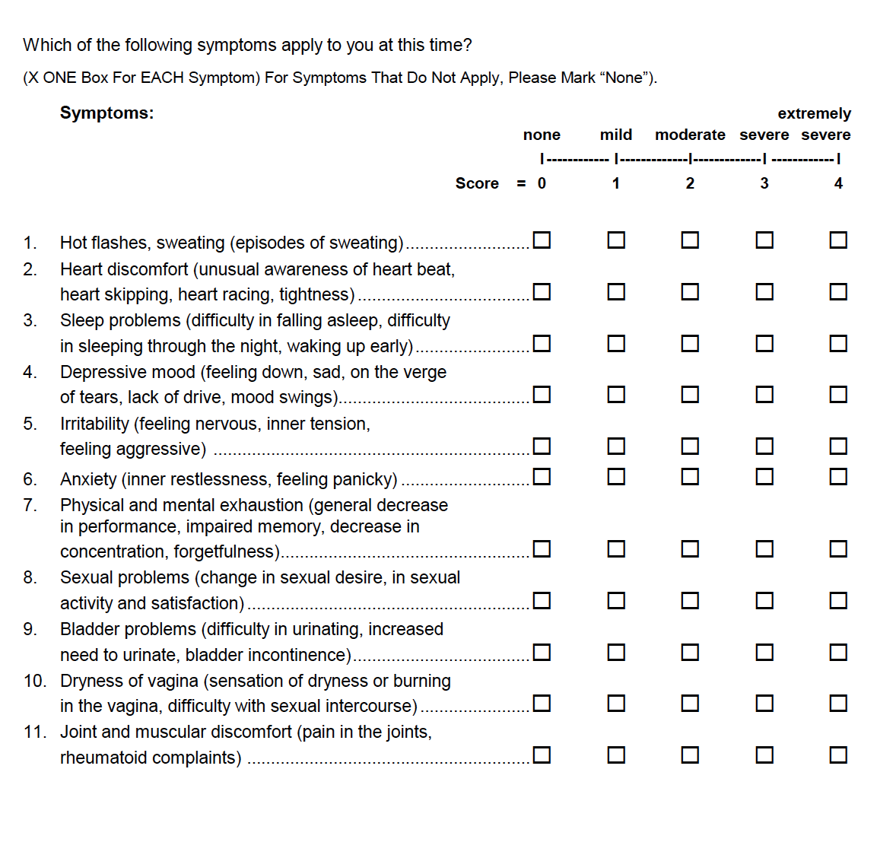

Appendix C: Clinic Process Flow Chart

Appendix D: Data Collection Dashboard
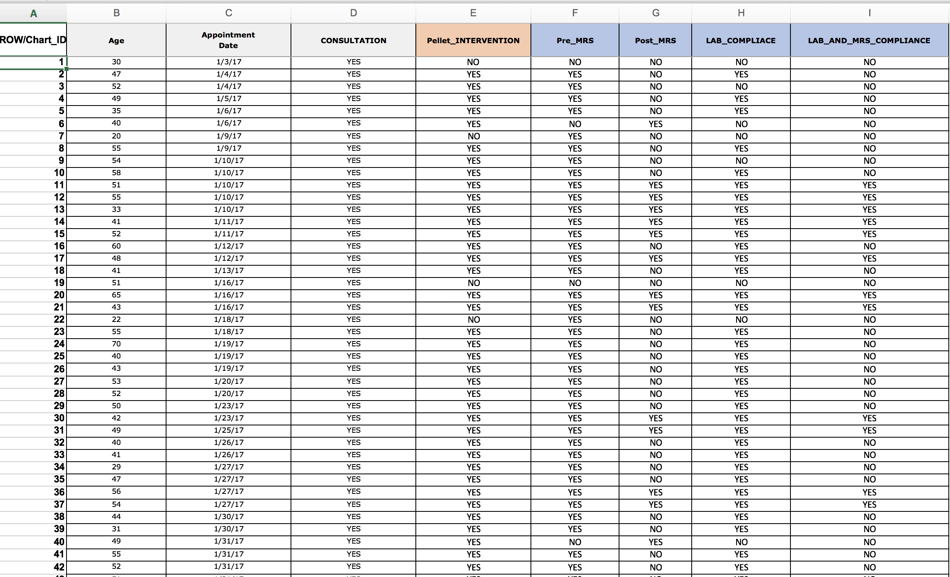
Appendix E: Pre/Post Intervention MRS Scores of Depression Dashboard
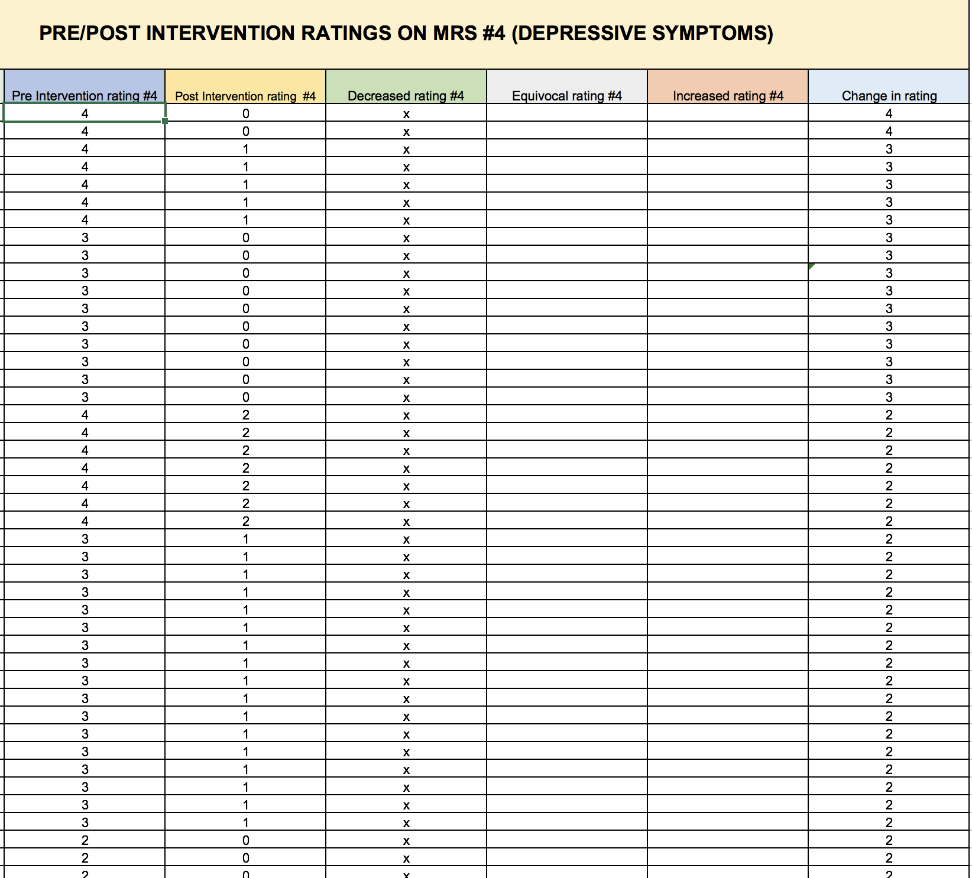
Appendix F: Mann-Whitney U Graph- Pre-and Post MRS Depression Score Comparison:
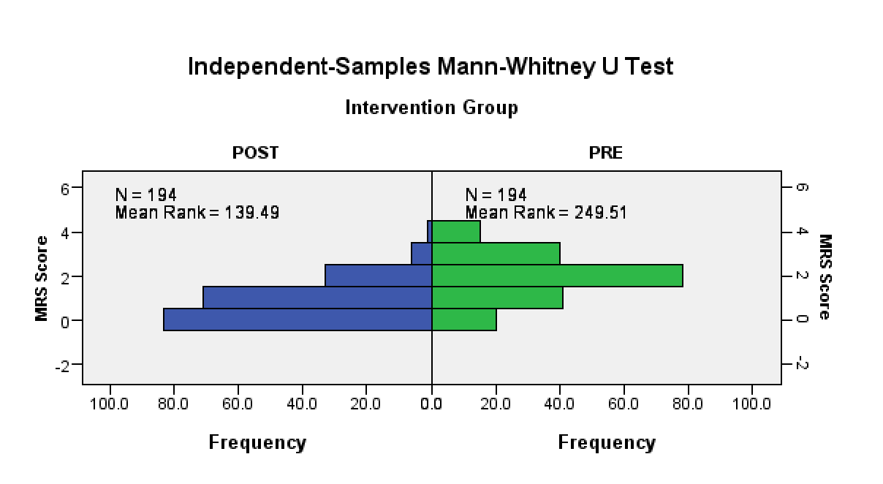
References
Ahsan, M., Mallick, A. K., Singh, R., & Prasad, R. R. (2015). Assessment of menopausal symptoms during perimenopause and post-menopause in tertiary care hospital. Journal of Basic and Clinical Reproductive Sciences, 4(1), 14-19.
Bachmann, G. A. (1999). Androgen co-therapy in menopause: Evolving benefits and challenges. American Journal of Obstetrics and Gynecology, 180(3), S308-S311.
Bosworth, H. B., Bastian, L. A., Kuchibhatla, M. N., Steffens, D. C., McBride, C. M.,
Skinner, C. S., & Siegler, I. C. (2001). Depressive symptoms, menopausal status, and climacteric symptoms in women at midlife. Psychosomatic Medicine, 63(4), 603-608.
Bray, P., Cummings, D. M., Wolf, M., Massing, M. W., & Reaves, J. (2009). After the collaborative is over: what sustains quality improvement initiatives in primary care practices? Joint Commission journal on quality and patient safety, 35(10), 502-508.
Bromberger, J. T., Matthews, K. A., Schott, L. L., Brockwell, S., Avis, N. E., Kravitz, H. M., Randolph, John F.,,Jr. (2007). Depressive symptoms during the menopausal transition: The study of women's health across the nation (SWAN). Journal of Affective Disorders, 103(1-3), 267-272.
Bromberger, J. T., Kravitz, H. M., Matthews, K., Youk, A., Brown, C., & Feng, W. (2009). Predictors of first lifetime episodes of major depression in midlife women. Psychological medicine, 39(1), 55-64.
Bromberger, J. T., Schott, L., Kravitz, H. M., & Joffe, H. (2015). Risk factors for major depression during midlife among a community sample of women with and without prior major depression: are they the same or different? Psychological medicine, 45(8), 1653-1664.
Bromberger, J. T., Kravitz, H. M., Youk, A., Schott, L. L., & Joffe, H. (2016). Patterns of depressive disorders across 13 years and their determinants among midlife women: SWAN mental health study. Journal of affective disorders, 206, 31-40.
Carnahan, R.M.& Perry, P.J. (2004). Depression in Aging Men: The role of testosterone. Aging Drugs, 21(6), 361-376.
Chedraui, P., Aguirre, W., Hidalgo, L., & Fayad, L. (2007). Assessing menopausal symptoms among healthy middle aged women with the Menopause Rating Scale. Maturitas, 57(3), 271-278.
Cherrier, M.M., Asthana, S., Plymate, S., Baker, L., Matsumoto, A.M., Peskind, E., Raskind, M.A., Brodkin, K., Bremner, W., Petrova, A., LaTendresse, S., & Craft, S. (2001). Testosterone supplementation improves spatial and verbal learning memory in healthy older men. Neurology, 57, 80-88.
Christensen, H., Griffiths, K., & Farrer, L. (2009). Adherence in Internet Interventions for Anxiety and Depression: A Systematic Review. Journal of Medical Internet Research, 11(2), 13-38.
Chuni, N., & Sreeramareddy, C. T. (2011). Frequency of symptoms, determinants of severe symptoms, validity of and cut-off score for Menopause Rating Scale (MRS) as a screening tool: a cross-sectional survey among midlife Nepalese women. BMC women's health,11(1), 30.
Davis, S. R., & Tran, J. (2001). Testosterone influences libido and well being in women. Trends in Endocrinology & Metabolism, 12(1), 33-37.
Davis, S. R., & Wahlin-Jacobsen, S. (2015). Testosterone in women—the clinical significance. The Lancet Diabetes & Endocrinology, 3(12), 980-992.
Dimitrakakis, C. (2011). Androgens and Breast Cancer in Men and Women. Journal of Endocrinology Metabolism Clinics of North America, 40, 533-537.
Dinger, J., & Heinemann, L. A. (2014). Menopause rating scale as outcome measure for hormone treatment. Retrieved from http://www.menopause-rating- scale.info/documents/poster.pdf
Ðoković, D.,D., Jović, J.,J., Ðoković, J.,D., Knežević, M. Ž., Djukić-Dejanović, S., & Ristić-Ignjatović, D.,I. (2015). Effects of hormone replacement therapy on depressive and anxiety symptoms after oophorectomy. Medicinski Glasnik: Official Publication of the Medical Association of Zenica-Doboj Canton, Bosnia and Herzegovina, 12(1), 79-85.
Ebinger, M., Sievers, C., Ivan, D., Schneider, H. J., & Stalla, G. K. (2008). Is there a neuroendocrinological rationale for testosterone as a therapeutic option in depression? Journal of Psychopharmacology. 23(7), 841-853.
Freeman, E. W., Sammel, M. D., Liu, L., Gracia, C. R., Nelson, D. B., & Hollander, L. (2004). Hormones and menopausal status as predictors of depression in women in transition to menopause. Archives of General Psychiatry, 61(1), 62-70.
Freeman, E. W., Sammel, M. D., Lin, H., & Nelson, D. B. (2006). Associations of hormones and menopausal status with depressed mood in women with no history of depression. Archives of general psychiatry, 63(4), 375-382.
Frye, C. A., & Walf, A. A. (2009). Depression-like behavior of aged male and female mice is ameliorated with administration of testosterone or its metabolites. Physiology & behavior, 97(2), 266-269.
Gerber, M. R., Cabral, H. J., Suglia, S. F., Joseph, R. C., & Fried, L. E. (2008). Patient Follow-Up in Primary Care After Behavioral Health Screening in an Urban Public Hospital System: A Prospective, Observational Study of 2686 Patients. Primary care companion to the Journal of clinical psychiatry, 10(6), 430.
Gerrity, M. S., Williams, J. W., Dietrich, A. J., & Olson, A. L. (2001). Identifying physicians likely to benefit from depression education: a challenge for health care organizations. Medical Care, 39(8), 856-866.
Gilbody, S., House, A., & Sheldon, T. (2001). Routinely administered questionnaires for depression and anxiety: systematic review. British Medical Journal, 322, 406- 409.
Gilbody, S., Bower, P., Fletcher, J., Richards, D., & Sutton, A. J. (2006). Collaborative care for depression: a cumulative meta-analysis and review of longer-term outcomes. Archives of internal medicine, 166(21), 2314-2321.
Glaser, R. & Dimitrakakis, C. (2013). Testosterone therapy in women: Myths and misconceptions. Maturitas, 74(3), 230; 230-234; 234.
Glaser, R., Dimitrakakis, C., Trimble, N., & Martin, V. (2012). Testosterone pellet implants and migraine headaches: A pilot study. Maturitas, doi:10.1016/j.maturitas.2012.01.006.
Glaser, R., Kalantaridou, S., & Dimitrakakis, C. (2013). Testosterone implants in women: Pharmacological dosing for a physiologic effect. Maturitas, 74(2), 179-184.
Glaser, R., York, A. E., & Dimitrakakis, C. (2011). Beneficial effects of testosterone therapy in women measured by the validated menopause rating scale (MRS). Maturitas, 68(4), 355-361.
Goldstat, R., Briganti, E., Tran, J., Wolfe, R., & Davis, S. R. (2003). Transdermal testosterone therapy improves well-being, mood, and sexual function in premenopausal women. Menopause, 10(5), 390-398.
Gyllstrom, M. E., Schreiner, P. J., & Harlow, B. L. (2007). Perimenopause and depression: strength of association, causal mechanisms and treatment recommendations. Best Practice & Research Clinical Obstetrics & Gynecology, 21(2), 275-292.
Haynes, R. B., McDonald, H. P., & Garg, A. X. (2002). Helping patients follow prescribed treatment: clinical applications. Jama, 288(22), 2880-2883.
Heinemann, K., Ruebig, A., Potthoff, P., Schneider, H. P., Strelow, F., & Heinemann, L. A. (2004). The Menopause Rating Scale (MRS) scale: a methodological review. Health and Quality of life Outcomes, 2(1), 45.
Hickey, M., Schoenaker, D. A., Joffe, H., & Mishra, G. D. (2016). Depressive symptoms across the menopause transition: findings from a large population-based cohort study. Menopause, 23(12), 1287-1293.
Hodosy, J., Zelmanová, D., Majzúnová, M., Filová, B., Malinová, M., Ostatníková, D., & Celec, P. (2012). The anxiolytic effect of testosterone in the rat is mediated via the androgen receptor. Pharmacology Biochemistry and Behavior, 102(2), 191-195.
.
Joffe, H., Crawford, S. L., Freeman, M. P., White, D. P., Bianchi, M. T., Kim, S., & Cohen, L. S. (2016). Independent Contributions of Nocturnal Hot Flashes and Sleep Disturbance to Depression in Estrogen-Deprived Women. The Journal of clinical endocrinology and metabolism, 101(10), 3847.
Joffe, H., & Hickey, M. (2018). Should Hormone Therapy Be Used to Prevent Depressive Symptoms During the Menopause Transition? JAMA psychiatry.
Jovanovic, H., Kocoska-Maras, L., Rådestad, A. F., Halldin, C., Borg, J., Hirschberg, A. L., & Nordström, A. L. (2015). Effects of estrogen and testosterone treatment on serotonin transporter binding in the brain of surgically postmenopausal women–a PET study. Neuroimage, 106, 47-54.
Kumsar, Ş., Kumsar, N. A., Sağlam, H. S., Köse, O., Budak, S., & Adsan, Ö. (2014). Testosterone levels and sexual function disorders in depressive female patients: effects of antidepressant treatment. The journal of sexual medicine, 11(2), 529.
Lambrinoudaki, I., Bouziou, G., Armeni, E., Spyropoulou, A., Koundi, K., Rizos, D., & Dendrinos, S. (2015). Circulating androgens are associated with mood disturbances in young postmenopausal women. Climacteric, 18(2), 205-213.
Maartens, L., Knottnerus, J., & Pop, V. (2002). Menopausal transition and increased depressive symptomatology: A community based prospective study. Maturitas, 42(3), 195-200.
Maclaran, K., & Panay, N. (2012). The safety of postmenopausal testosterone therapy. Women's Health, 8(3), 263-275.
McDonald, H. P., Garg, A. X., & Haynes, R. B. (2002). Interventions to enhance patient adherence to medication prescriptions: scientific review. Jama, 288(22), 2868- 2879.
McHenry, J., Carrier, N., Hull, E., & Kabbaj, M. (2014). Sex differences in anxiety and depression: Role of testosterone. Frontiers in Neuroendocrinology, 35(1), 42-57.
Melnyk, B. M., & Fineout-Overholt, E. (2015). Evidence-based practice in nursing & healthcare. 3rd.
Miller, K. K., Perlis, R. H., Papakostas, G. I., Mischoulon, D., Iosifescu, D. V., Brick, D. J., & Fava, M. (2009). Low-dose transdermal testosterone augmentation therapy improves depression severity in women. CNS spectrums, 14(12), 688-694.
Miller, K. K., Rosner, W., Lee, H., Hier, J., Sesmilo, G., Schoenfeld, D.,& Klibanski, A. (2004). Measurement of free testosterone in normal women and women with androgen deficiency: comparison of methods. The Journal of Clinical Endocrinology & Metabolism, 89(2), 525-533.
Miller, K. K., Wexler, T. L., Zha, A. M., Lawson, E. A., Meenaghan, E. M., Misra, M., & Klibanski, A. (2007). Androgen deficiency: association with increased anxiety and depression symptom severity in anorexia nervosa. The Journal of clinical psychiatry, 68(6), 959-965.
Moravcová, M., Ježek, S., Mareš, J., & Vachková, E. (2014). Czech version of Menopause Rating Scale Questionnaire—Preliminary notice. Kontakt, 16(2), e94-e101.
Nappi, R.E. & Lachowsky, M. (2009). Menopause and sexuality: Prevalence of symptoms and impact on quality of life. Maturitas, 63, 138-141.
O'Connor, E. A., Whitlock, E. P., Beil, T. L., & Gaynes, B. N. (2009). Screening for depression in adult patients in primary care settings: a systematic evidence review. Annals of internal medicine, 151(11), 793-803.
Osborne, D. M., Edinger, K., & Frye, C. A. (2009). Chronic administration of androgens with actions at estrogen receptor beta have anti-anxiety and cognitive-enhancing effects in male rats. Age, 31(3), 191-198.
Panay, N., & Fenton, A. (2009). The role of testosterone in women. Climacteric, 12(3), 185-187.
Parand, A., Benn, J., Burnett, S., Pinto, A., & Vincent, C. (2012). Strategies for sustaining a quality improvement collaborative and its patient safety gains. International Journal for Quality in Health Care, 24(4), 380-390.
Pignone, M. P., Gaynes, B. N., Rushton, J. L., Burchell, C. M., Orleans, C. T., Mulrow, C. D., & Lohr, K. N. (2002). Screening for depression in adults: a summary of the evidence for the US Preventive Services Task Force. Annals of internal medicine, 136(10), 765-776.
Rahman, S. A. S. A., Zainudin, S. R., & Mun, V. L. K. (2010). Assessment of menopausal symptoms using modified Menopause Rating Scale (MRS) among middle age women in Kuching, Sarawak, Malaysia. Asia Pacific Family Medicine, 9(1), 5.
Rech, C. M. Z., Clapauch, R., de Souza, M. D. G. C., & Bouskela, E. (2016). Low testosterone levels are associated with endothelial dysfunction in oophorectomized early postmenopausal women. European journal of endocrinology, 174(3), 297-306.
Rohr, U. D. (2002). The impact of testosterone imbalance on depression and women's health. Maturitas, 41 Suppl 1, S25-S46.
Sands, R. & Studd, J. (1995). Exogenous Androgens in Postmenopausal Women. The American Journal of Medicine, 98(1A), 76-79.
Schmidt, P. J., Dor, R. B., Martinez, P. E., Guerrieri, G. M., Harsh, V. L., Thompson, K., & Rubinow, D. R. (2015). Effects of estradiol withdrawal on mood in women with past peri-menopausal depression: a randomized clinical trial. JAMA psychiatry, 72(7), 714-726.
Schoen, C., Osborn, R., Huynh, P. T., Doty, M., Peugh, J., & Zapert, K. (2006). On the front lines of care: primary care doctors’ office systems, experiences, and views in seven countries. Health Affairs, 25(6), w555-w571.
Schoenbaum, M., Unützer, J., Sherbourne, C., Duan, N., Rubenstein, L. V., Miranda, J., & Wells, K. (2001). Cost-effectiveness of practice-initiated quality improvement for depression: results of a randomized controlled trial. Jama, 286(11), 1325- 1330.
Schutter, D. J., Peper, J. S., Koppeschaar, H. P., Kahn, R. S., & van Honk, J. (2005). Administration of testosterone increases functional connectivity in a cortico- cortical depression circuit. The Journal of neuropsychiatry and clinical neurosciences, 17(3), 372-377.
Sherbourne, C. D., Wells, K. B., Duan, N., Miranda, J., Unützer, J., Jaycox, L., & Rubenstein, L. V. (2001). Long-term effectiveness of disseminating quality improvement for depression in primary care. Archives of General Psychiatry, 58(7), 696-703.
Sherman, S. (2005). Defining the menopausal transition. The American journal of medicine, 118(12), 3-7.
Soares, C. N., Poitras, J. R., & Prouty, J. (2003). Effect of reproductive hormones and selective estrogen receptor modulators on mood during menopause. Drugs & Aging, 20(2), 85-100.
Soares, C. N. (2017). Tailoring strategies for the management of depression in midlife years. Menopause, 24(6), 699-701.
Studd, J., & Panay, N. (2004). Hormones and depression in women. Climacteric: The Journal of the International Menopause Society, 7(4), 338-346.
Thombs, B. D., Coyne, J. C., Cuijpers, P., De Jonge, P., Gilbody, S., Ioannidis, J. P., & Ziegelstein, R. C. (2012). Rethinking recommendations for screening for depression in primary care. Canadian Medical Association Journal, 184(4), 413- 418.
Utian, W. H. (1994). Ovarian function, therapy-oriented definition of menopause and climacteric. Experimental Gerontology, 29(3), 245-251.
Wells, K. B., Sherbourne, C., Schoenbaum, M., Duan, N., Meredith, L., Unützer, J., & Rubenstein, L. V. (2000). Impact of disseminating quality improvement programs for depression in managed primary care: a randomized controlled trial. Jama, 283(2), 212-220.
Wells, K., Sherbourne, C., Schoenbaum, M., Ettner, S., Duan, N., Miranda, J., & Rubenstein, L. (2004). Five-year impact of quality improvement for depression: results of a group-level randomized controlled trial. Archives of General Psychiatry, 61(4), 378-386.
Williams Jr, J. W., Rost, K., Dietrich, A. J., Ciotti, M. C., Zyzanski, S. J., & Cornell, J. (1999). Primary care physicians' approach to depressive disorders: effects of physician specialty and practice structure. Archives of Family Medicine, 8(1), 58.
Woods, N. F., & Mitchell, E. S. (2005). Symptoms during the peri-menopause: prevalence, severity, trajectory, and significance in women’s lives. The American journal of medicine, 118(12), 14-24.
Wuttke, W., Seidlova-Wuttke, D., & Gorkow, C. (2003). The Cimicifuga preparation BNO 1055 vs. conjugated estrogens in a double-blind placebo-controlled study: effects on menopause symptoms and bone markers. Maturitas, 44, S67-S77.
Zarrouf, F. A., Artz, S., Griffith, J., Sirbu, C., & Kommor, M. (2009). Testosterone and depression: systematic review and meta-analysis. Journal of Psychiatric Practice, 15(4), 289-305.

